A000-EUR**-Scotland**-Petroglyph Panel-Anthropomorph-H Figures-Malachite-Pictish Culture-5400-4700 BCE

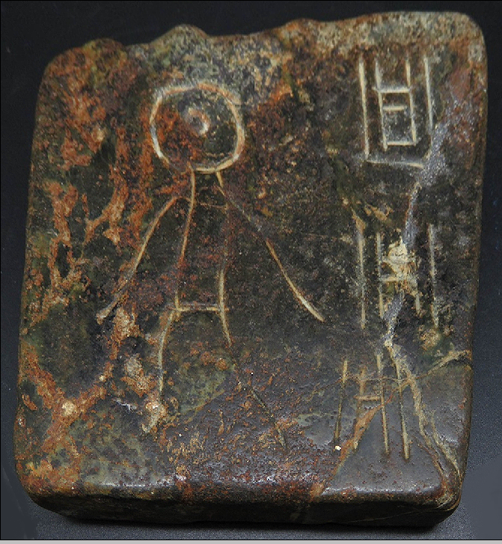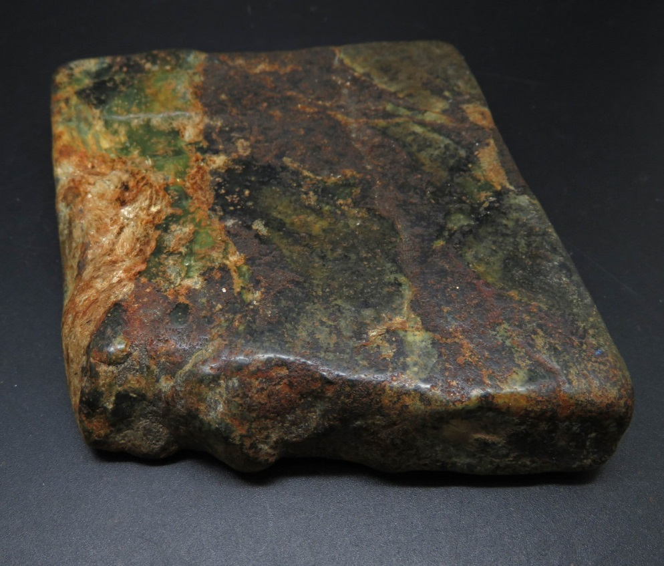

Figs. 1-2. **Serbia-**Pločnik-Vinca Culture-Petroglyph Panel-Anthropomorph and Three Copper-incised H Figures-Polished Malachite Ore-Chalcolithic Period-5400-4700 BCE

**Case No.: 3**

**Accession No.**

**Formal Label:**

**Display Description:**

Pictish stones have been classified into three groups.[[2]](https://en.wikipedia.org/wiki/Pictish_stone#cite_note-2) in which both Class I and II stones were being produced simultaneously. This stone falls into Class 1..[[3]](https://en.wikipedia.org/wiki/Pictish_stone" \l "cite_note-pictishstones.org.uk-3)

* **Class 1** — unworked stones with symbols only incised. There is no [cross](https://en.wikipedia.org/wiki/Cross) on either side. Class 1 stones date back to the 6th, 7th and 8th century.
* **Class 2** — stones of more or less rectangular shape with a large cross and symbol(s) on one or both sides.
* **Class 3** — these stones feature no idiomatic Pictish symbols. The stones can be cross-slabs, recumbent gravemarkers, free-standing crosses, and composite stone shrines. They originate in the 8th or 9th century.

Allen, J.R.; Anderson, J. (1903), *Early Christian Monuments of Scotland*, Balgavies, Angus: Pinkfoot Press (1993

The Copper Age or the Chalcolithic Period began with the Vinča culture in Eastern Europe at the 6th millennium site of Pločnik in the municipality of Prokuplje, Toplica District, Republic of Serbia in which a copper axe from 5500 BCE was excavated belonging to the Vinča culture).

     One of the most exciting finds for archaeologists was the discovery of a sophisticated metal workshop with a furnace and tools including a copper chisel and a two-headed hammer and axe. "This might prove that the Copper Age started in Europe at least 500 years earlier than we thought," Kuzmanovic said. The Copper Age marks the first stage of humans’ use of metal, with copper tools used alongside older stone implements. It is thought to have started around the 4th millennium BCE in southeast Europe, and earlier in the Middle East. The Vinca culture flourished from 5500 to 4000 BCE on the territories of what is now Bosnia, Serbia, Romania and the Former Yugoslav Republic of Macedonia. It got its name from the present-day village of Vinca, 10 km east of Belgrade on the Danube River, where early 20th-century excavations uncovered the remains of eight Neolithic villages.  
     The discovery of a mine at the nearby Mlava river suggested at the time that Vinca could be Europe’s first metal culture, a theory now backed up by the Plocnik site. "These latest findings show that the Vinca culture was from the very beginning a metallurgical culture," said archaeologist Dusan Sljivar of Serbia’s National Museum. "They knew how to find minerals, to transport th Pločnik was a room of some 25 square meters, with walls built out of wood coated with clay. The furnace, built on the outside of the room, featured earthen pipe-like air vents with hundreds of tiny holes in them and a prototype chimney to ensure air goes into the furnace to feed the fire and smoke comes out safely. Sljivar said the early metal workers very likely experimented with colorful minerals that caught their eye – blue azurite, bright green malachite and red cuprite, all containing copper – as evidenced by malachite traces found on the inside of a pot.  
(After Reuters, 11 November 2007, Kathimerini, 16 November 2007.)

**LC Classification:** GN776.2.V5

**Date or Time Horizon:** Middle Neolithic/Copper Age-5500-4500 BCE.

**Geographical Area:** SE Europe

**Map:**

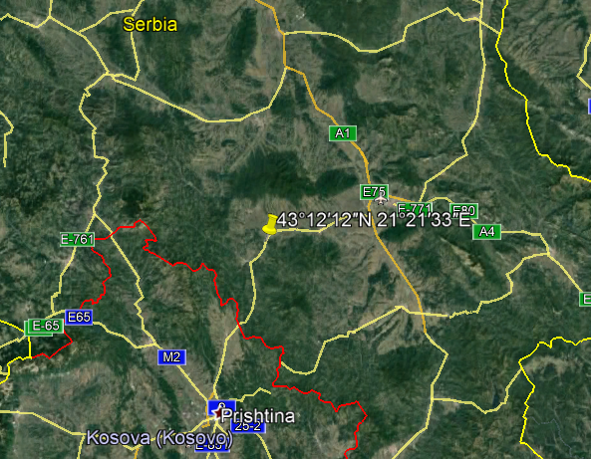

**GPS coordinates:** Pločnik [43°12′12″N 21°21′33″E](https://tools.wmflabs.org/geohack/geohack.php?pagename=Plo%C4%8Dnik&params=43_12_12_N_21_21_33_E_region:RS_type:city(182))



Fig. 5. Map of the extent of Vinča culture. Adapted after Kaiser and Voytek (1983: 333, fig. 1) and Chapman (1981); from https://www.ucl.ac.uk/silva/rise-metallurgy-eurasia/images/5.1.jpg?hires



Fig. 6. Map of the Central Balkans. Beograd = Belgrade, Serbia, and the approximate location of the Vinča Belo-Brdo site. From http://drakenberg.weebly.com/uploads/6/7/4/7/6747442/9582880.jpg?578

**Cultural Affiliation:** Vinča Culture

**Medium:** clay

**Dimensions:** H 174.74 mm, 6.76 in

**Weight: 258 gm, 9 oz**

**Provenance:** Anglo-Antiquities, 33 Medlock Grove, Didcot, Oxfordshire, ox11 7xy, United Kingdom

**Discussion:**

The Vinča culture was named for its type site, Vinča-Belo Brdo tell or mound, on the right bank of the Danube River in Belgrade, Serbia.

The Vinča culture emerged at the inception of the Middle Neolithic/Copper or Chacolithic Age (5500-4500 BCE) with origins that are debated as either having derived from the earlier Starčevo culture (6200-4500 BCE) of the area, which has been reputed to have been the source of a Proto Indo-European language (PIE), or from migrations from a PIE homeland of a Kurgan or mound-building culture in the Pontic steppe north of the Black Sea (The Kurgan Hypothesis).

Vinča settlers initiated a cultural uniformity that they expressed in farming, making dark pottery fired under reducing conditions comprising zoomorphic and anthropomorphic figurines and making clay tablets with so-called Vinča symbols, which have the appearance of proto-writing (Winn Luca 2008: 26). The type site of the Vinča-Belo Brdo comprised 7 m of Vinča cultural debris overlying 2 m of the previous Starčevo culture. Elsewhere in Serbia and the western part of Romania large Vinča tell villages ranged up to 100 ha in size.

Early phase anthropomorphic figurines from this site have triangular heads, flat bodies with short outstretched arms and closed legs. The treatment of facial and body features was done by simple incisions into the clay without modeling. Later phase anthropomorphic figurines are more polygonal, with more pronounced facial features, such as modeled noses and distinctive half-moon eyes and modeled arms. For both periods no indication of a mouth is present. Some theorize that these figurines are deities for ritual practice, while others see them as ancestral cult objects.

"According to the figurines we found, young women were beautifully dressed, like today's girls in short tops and mini skirts, and wore bracelets around their arms," said archaeologist Julka Kuzmanovic-Cvetkovic.  
     The unnamed tribe who lived between 5400 and 4700 BCE in the 120-hectare site at what is now Plocnik knew about trade, handcrafts, art and metallurgy. Near the settlement, a thermal well might be evidence of Europe’s oldest spa. "They pursued beauty and produced 60 different forms of wonderful pottery and figurines, not only to represent deities, but also out of pure enjoyment," said Kuzmanovic.  
The findings suggest an advanced division of labor and organization. Houses had stoves, there were special holes for trash, and the dead were buried in a tidy necropolis. People slept on woollen mats and fur, made clothes of wool, flax and leather, and kept animals.  
The community was especially fond of children. Artefacts include toys such as animals and rattles of clay, and small, clumsily crafted pots apparently made by children at playtime.     The settlement was destroyed at some point, probably in the first part of the 5th millennium, by a huge fire. The Plocnik site was first discovered in 1927 when the then Kingdom of Serbs, Croats and Slovenes was building a rail line. Some findings were published at the time but war, lack of funds and objections from farmers meant it was investigated only sporadically until digging started in earnest in 1996. "The saddest thing for us is always the moment when we finish our work and everything has to be covered up with earth again," Kuzmanovic said. "That’s the easiest for the state; conservation is very expensive and the land owners want to work in their fields." But there was some hope that the latest excavation would be preserved due to its importance, Kuzmanovic added.

(After Reuters, 11 November 2007, Kathimerini, 16 November 2007.)

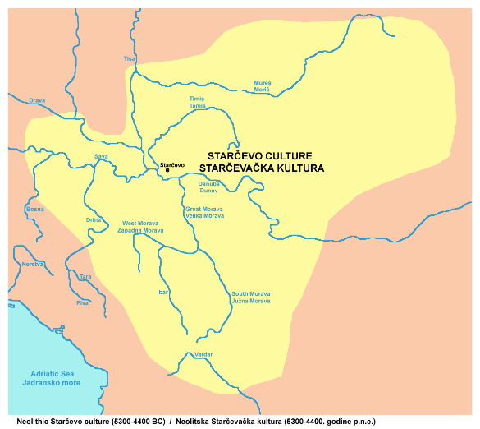

Fig. 7. The extent of the Starčevo culture (6200-4500 BCE) in southeast Europe. After <https://upload.wikimedia.org/wikipedia/commons/thumb/e/ea/Starcevo_culture.png/450px-Starcevo_culture.png>

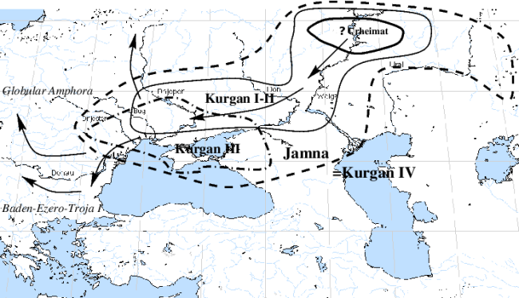

Fig.8. Overview of [Marija Gimbutas](https://commons.wikimedia.org/w/index.php?title=Marija_Gimbutas&action=edit&redlink=1)' [Kurgan](https://commons.wikimedia.org/w/index.php?title=Kurgan&action=edit&redlink=1) hypothesis showing the PIE migrations from the Pontic Steppes into southeastern Europe. Made by [en:User:Dbachmann](https://en.wikipedia.org/wiki/User:Dbachmann) and originally at [en:Image:Kurgan map.png](https://en.wikipedia.org/wiki/Image:Kurgan_map.png).

**References:**

Biagi, P. Gratuze, B. and Boucetta, S. 2007. “New data on the archaeological obsidians from Banat and Transylvania (Romania).” In M. Spataro and P. Biagi (eds.) *A short walk through the Balkans: The first farmers of the Carpathian basin and Adjacent regions*. Quaderno 12. Trieste: Societa per la preistoria e protoistoria della regione Friuli-Venezia Giulia, pp. 129-39.

Chapman, J. 1981. *The Vinča Culture of South East Europe. Studies in chronology, economy and society*. British Archaeological Reports, International Series 117, Oxford: Archeopress. 2v.

Gimbutas, Marija. 1970. “Proto-Indo-European Culture: The Kurgan Culture during the Fifth, Fourth, and Third Millennia B.C.” In Cardona, George; Hoenigswald, Henry M.; Senn, Alfred, Indo-European and Indo-Europeans: Papers Presented at the Third Indo-European Conference at the University of Pennsylvania. Philadelphia: University of Pennsylvania Press, pp. 155–197.

Haak, Wolfgang *et al*. 2015. “Massive migration from the steppe is a source for Indo-European languages in Europe.” bioRxiv preprint first posted online Feb. 10, 2015; doi: http://dx.doi.org/10.1101/013433 Now published in *Nature* doi: [10.1038/nature14317](http://dx.doi.org/10.1038/nature14317)

Holmberg, E.J. 1964. “The Appearance of Neolithic Black Burnished Ware in Mainland Greece,” *American Journal of Archaeology* 68(4): 343-8.

Kaiser, T. and B. Voytek. 1983. “Sedentism and economic change in the Balkan Neolithic,” *Journal of Anthropological Archaeology* 2(4): 323-353.

Luca, S. A. 2008. “The Neolithic and Eneolithic periods in Transylvania.” In Institute of Archaeomythology and Muzeul Brukenthal, *The Danube script: Neo-eneolithic writing in southeastern Europe* [exhibition catalogue]. Sebastopol, California, Institute of Archaeomythology, pp. 23-38,

Özdoğan, M. 2003. “The Prehistory of Northwestern Turkey - The synoptic overview of the latest evidence.” In D.V. Grammenos (ed.) *Recent Research in the Prehistory of the Balkans*. Thessaloniki: Archaeological Institute of Northern Greece and the Archaeological Receipts Fund, pp. 329- 68.

Thissen, L. (2001) “Time trajectories for the Neolithic of Central Anatolia, CANeW project,” http://www.canew.org/files/Thissen%20lecture.pdf, [23.11.2001]: 1-26.

─── (2007) “CANeW Central Anatolia and Cilicia 14C Chart, CANeW project,” http://www.canew.org/cachronobox.html, updated at 16.03.2007.

Vasic, Mīloje M. 1932-1936. *Preistoriska Vinča*. Beograd [Belgrade]: Državne Štamparije. 4 v.

Winn, Milton MacChesney. 1981. [*Pre-writing in Southeastern Europe: the sign system of the Vinča culture ca. 4000 B.C.*](http://www.worldcat.org/title/pre-writing-in-southeastern-europe-the-sgin-system-of-the-vinca-culture-ca-4000-bc/oclc/781534609&referer=brief_results) Calgary, Alberta: Western Publishers.

**References:**

Reuters, 11 November 2007, Kathimerini, 16 November 2007